Giant Mountains
Traveling Salesman Problem

You are planning a tourist trip from Labska Bouda where you are staying now. Recommended places to meet are Martinova Bouda, Snezne Jamy, Vrbatova Bouda, Petrova Bouda and Davidovy Boudy (see the map below). The table below shows distances between locations in kilometres.

The objective is to plan the shortest cycle using the tourist signs.
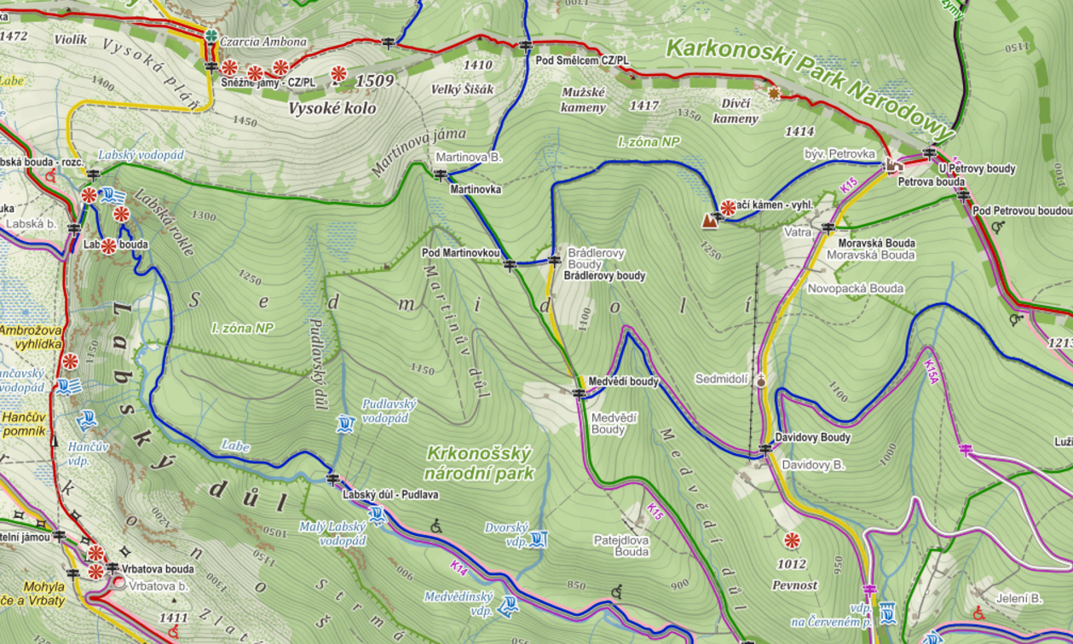
Vrbatova Bouda
Labská Bouda
Martinova Bouda
Sněžné jámy
Petrova Bouda
Davidovy Boudy

 | LB | MB | SJ | VB | PB | DB
LB | 0 | 2,4 | 1,9 | 2,3 | 5,8 | 5,6
MB | 2,4 | 0 | 3,1 | 4,7 | 3,4 | 3,2
SJ | 1,9 | 3,1 | 0 | 4,2 | 4,4 | 6,3
VB | 2,3 | 4,7 | 4,2 | 0 | 8,1 | 7,9
PB | 5,8 | 3,4 | 4,4 | 8,1 | 0 | 2,1
DB | 5,6 | 3,2 | 6,3 | 7,9 | 2,1 | 0

